

INSTITUTE FOR ADVANCED COMPUTING
AND
SOFTWARE DEVELOPMENT
AKURDI, PUNE

Documentation On

“ONLINE BOOK STORE”
PG-DAC Feb-2019

Submitted By :
Group No: 75
Sameer Borkar(1134)
Mayur Mohurle(1158)

Mr.Prashant Karhale Mr. Akshay
Centre Coordinator Project Guide

Abstract

The business-to-consumer aspect of electronic commerce (e-commerce) is the most visible
business use of the World Wide Web. The primary goal of an e-commerce site is to sell goods
and services online.

This project deals with developing an e-commerce website for Online Book Sale. It provides the
user with a catalog of different books available for purchase in the store. In order to facilitate
online purchase a shopping cart is provided to the user. The system is implemented using a 3-tier
approach, with a backend database, a middle tier of Sun J2EE 1.4 application server and JSP, and
a web browser as the front end client.

In order to develop an e-commerce website, a number of Technologies must be studied and
understood. These include multi-tiered architecture, server and client side scripting techniques,
implementation technologies such as JSP, programming language (such as JAVA, JavaScript,
and HTML), relational databases (such as MySQL, Access).

This is a project with the objective to develop a basic website where a consumer is provided with
a shopping cart application and also to know about the technologies used to develop such an
application.

This document will discuss each of the underlying technologies to create and implement an ebook
store.

TABLE OF CONTENTS

Table of Contents……………………………………………………………………3
List of Figures…………………………………………………………………………4
- Introduction………………………………………………………………………………………….5
- Literature Review………………………………………………………………………………...5
- Implementation Technologies………………………………………………………….….7
3.1. Introduction to JSP(J2EE 1.4)……………………………………………….…..7
3.2. JSP Architecture…………………………………………………………………….…..7
3.2.1 Access Model………………………………………………………………………9
3.3. MySql Database………………………………………………………………………..11
3.4 Integration the Website and Database…………………………………….11
4.0. Web Page Programming options………………………………………………………….12
5.0. The Shopping Cart Application…………………………………………………………….13
6.0. Project Design……………………………………………………………………………………...14
6.1. Data Model………………………………………………………………………………….14
6.1.1 Database Design…………………………………………………………………15
6.2. Process Model………………………………………………………………………….…16
6.2.1 Functional Decomposition Diagram………………………………….16
6.2.2 Data Flow Diagram(DFD)………………………………………………….17
6.3 Screenshots…………………………………………………………………………..26
7.0. Limitations and Furture Development……………………………………………………31
8.0. Conclusion……………………………………………………………………………………………….32
9.0. Biblography …………………………………………………………………………………………….33

Index…………………………………………………………………………………………………………………..

List of Figures

Figure 1 Servlet Container…………………………………………………………………………………8
Figure 2 JSP servlet………………………………………………………………………………………….9
Figure 3. Access Model………………………………………………………………………………………9
Figure 4 MVC Design Pattern…………………………………………………………………………….10
Figure 5 Web Programming Option…………………………………………………………………..13
Figure 6 Entity relationship diagram…………………………………………………………………15
Figure 7 Class Diagram……………………………………………………………………………………..16
Figure 8 Functional Decomposition Diagram…………………………………………………….17
Figure 9 Context Level Diagram………………………………………………………………………..18
Figure 10 First Level DFD…………………………………………………………………………………..19
Figure 11 Second Level DFD………………………………………………………………………………20
Figure 12 ER Diagram………………………………………………………………………………………..21
Figure 13 Usecase Diagram……………………………………………………………………………….21
Figure 14 Customer Browse Context DFD…………………………………………………………22
Figure 15 Customer Browse Detailed DFD………………………………………………………..22
Figure 16 Customer Shoppingcart Context DFD……………………………………………….23
Figure 17 Customer Shoppingcart detailed DFD……………………………………………….23
Figure 18 Customer-Authenticaton Context DFD……………………………………………..24
Figure 18Customer-Authenticaton PurchesHistory DFD……………………………………24
Figure 19 Customer Authentication UserProfile DFD…………………………………………25
Figure 20 Authentication User-Purchase context………………………………………………25
Figure 20 Homepage…………………………………………………………………………………………..26
Figure 21Admin Login…………………………………………………………………………………………26
Figure 22 Admin Hime………………………………………………………………………………………..27
Figure 23 Admin Book Inventory……………………………………………………………………….27
Figure 24 Admin Book Update……………………………………………………………………………28
Figure 25 Admin Book Add…………………………………………………………………………………28
Figure 26 Admin Customer List………………………………………………………………………….29
Figure 27 Customer Login………………………………………………………………………………….29
Figure 28 Customer Homepage………………………………………………………………………….30
Figure 29 Customer Book List To Add……………………………………………………………….30
Figure 30 View Book Details And Add to Cart…………………………………………………..31

- Introduction

In the world of software development there lots of improvement in the area of
Architectural design and principles. The philosophies and implementation details are
changing as the people guiding the development of the application. In this fantastic
and yet sometimes complex world of software development there are some tried and
true architecture patterns and software development guidelines employed by most
architects. Also your design must have an ability to turn towards innovation instead of
lending itself to common practices. Web services are one such area where architects
must lean on their creative side and hope that their solutions are still successful. In
this report we will explain an exciting voyage down the road of Web services
application. From requirements to use cases, to database design, to component
frameworks, to user interfaces, we will cover each and every aspect of system design
required to build an application with collaborative Web services. The reason why we
selected online Bookstore web service is everybody walking down the street has some
idea about bookstores. The objective of this project is to develop an e- book store
where books can be bought from the comfort of home through the Internet.
An online book store is a virtual store on the Internet where customers can browse the
catalog and select books of interest. The selected books may be collected in a
shopping cart. At checkout time, the items in the shopping cart will be presented
as an order. At that time, more information will be needed to complete the transaction.
Usually, the customer will be asked to fill or select a billing address, a shipping
address, a shipping option, and payment information such as credit card number.
An e- mail notification is sent to the customer as soon as the order is placed.

- Literature Review

Electronic Commerce (e-commerce) applications support the interaction between
different parties participating in a commerce transaction via the network, as well as
the management of the data involved in the process [2].
The increasing importance of e-commerce is apparent in the study conducted by
researchers at the GVU (Graphics, Visualization, and Usability) Center at the Georgia
Institute of Technology. In their summary of the findings from the eighth survey, the
researchers report that "e-commerce is taking off both in terms of the number of users
shopping as well as the total amount people are spending via Internet based transactions".
Over three quarters of the 10,000 respondents report having purchased items online.
The most cited reason for using the web for personal shopping was convenience
(65%), followed by availability of vendor information (60%), no pressure from sales
person (55%) and saving time (53%).
Although the issue of security remains the primary reasons why more people do not
purchase terms online, the GVA survey also indicates that faith in the security of
ecommerce is increasing. As more people gain confidence in current encryption
technologies, more and more users can be expected to frequently purchase items
online [11].

A good e-commerce site should present the following factors to the customers for
better usability [11]:

• Knowing when an item was saved or not saved in the shopping cart.
• Returning to different parts of the site after adding an item to the shopping
cart.
• Easy scanning and selecting items in a list.
• Effective categorical organization of products.
• Simple navigation from home page to information and order links for specific
products.
• Obvious shopping links or buttons.
• Minimal and effective security notifications or messages.
• Consistent layout of product information.

Another important factor in the design of an e-commerce site is feedback [4]. The
interactive cycle between a user and a web site is not complete until the web site
responds to a command entered by the user. According to Norman [5], "feedback--
sending back to the user information about what action has actually been done, what
result has been accomplished--is a well known concept in the science of control and
information theory. Imagine trying to talk to someone when you cannot even hear
your own voice, or trying to draw a picture with a pencil that leaves no mark: there
would be no feedback".

Web site feedback often consists of a change in the visual or verbal information
presented to the user. Simple examples include highlighting a selection made by the
user or filling a field on a form based on a user's selection from a pull down list.
Another example is using the sound of a cash register to confirm that a product has
been added to an electronic shopping cart.

Completed orders should be acknowledged quickly. This may be done with an
acknowledgment or fulfillment page. The amount of time it takes to generate and
download this page, however, is a source of irritation for many e-commerce users.

Users are quick to attribute meaning to events. A blank page, or what a user perceives
to be "a long time" to receive an acknowledgment, may be interpreted as "there must
be something wrong with the order." If generating an acknowledgment may take
longer than what may be reasonably expected by the user, then the design should
include intermediate feedback to the user indicating the progress being made toward
acknowledgment or fulfillment.

Finally, feedback should not distract the user. Actions and reactions made by the web
site should be meaningful. Feedback should not draw the user's attention away from
the important tasks of gathering information, selecting products, and placing orders.

- Implementation Technologies

3.1 Introduction to JSP
While there are numerous technologies for building web applications that serve
dynamic content, the one that has really caught the attention of the development
community is JavaServer Pages (JSP). And not without ample reason either. JSP not
only enjoys cross-platform and cross-Web-server support, but effectively melds the
power of server-side Java technology with the WYSIWYG features of static HTML
pages.

JSP pages typically comprise of:
• Static HTML/XML components.
• Special JSP tags

Optionally, snippets of code written in the Java programming language called
"scriptlets." Consequently, you can create and maintain JSP pages by conventional
HTML/XML tools. It is important to note that the JSP specification is a standard
extension defined on top of the Servlet API. Thus, it leverages all of your experience
with servlets. There are significant differences between JSP and servlet technology.
Unlike servlets, which is a programmatic technology requiring significant developer
expertise, JSP appeals to a much wider audience. It can be used not only by
developers, but also by page designers, who can now play a more direct role in the
development life cycle. Another advantage of JSP is the inherent separation of
presentation from content facilitated by the technology, due its reliance upon reusable
component technologies like the JavaBeans component architecture and Enterprise
JavaBeans technology. This course provides you with an in-depth introduction to this
versatile technology, and uses the Tomcat JSP 1.1 Reference Implementation from the
Apache group for running the example programs.

  - JSP Architecture

The purpose of JSP is to provide a declarative, presentation-centric method of
developing servlets. As noted before, the JSP specification itself is defined as a
standard extension on top the Servlet API. Consequently, it should not be too
surprisingly that under the covers, servlets and JSP pages have a lot in common.
Typically, JSP pages are subject to a translation phase and a request processing phase.
The translation phase is carried out only once, unless the JSP page changes, in which
case it is repeated. Assuming there were no syntax errors within the page, the result is
a JSP page implementation class file that implements the Servlet interface, as shown
below.

Figure 1 Servlet Container

The translation phase is typically carried out by the JSP engine itself, when it receives
an incoming request for the JSP page for the first time. Note that the JSP 1.1
specification also allows for JSP pages to be precompiled into class files.

Precompilation may be especially useful in removing the start-up lag that occurs when
a JSP page delivered in source form receives the first request from a client. Many
details of the translation phase, like the location where the source and class files are
stored are implementation dependent.

The JSP page implementation class file extends HttpJspBase, which in turn
implements the Servlet interface. Observe how the service method of this class,
_jspService(), essentially inlines the contents of the JSP page. Although _jspService()
cannot be overridden, the developer can describe initialization and destroy events by
providing implementations for the jspInit() and jspDestroy() methods within their JSP
pages.

Once this class file is loaded within the servlet container, the _jspService() method is
responsible for replying to a client's request. By default, the _jspService() method is
dispatched on a separate thread by the servlet container in processing concurrent
client requests, as shown below:

Figure 2 JSP servlet

    - JSP Access Models

The early JSP specifications advocated two philosophical approaches, popularly
known as Model 1 and Model 2 architectures, for applying JSP technology. These
approaches differ essentially in the location at which the bulk of the request
processing was performed, and offer a useful paradigm for building applications using
JSP technology.

Consider the Model 1 architecture, shown below:

Figure 3. Access Model

In the Model 1 architecture, the incoming request from a web browser is sent directly
to the JSP page, which is responsible for processing it and replying back to the client.
There is still separation of presentation from content, because all data access is
performed using beans.

Although the Model 1 architecture is suitable for simple applications, it may not be
desirable for complex implementations. Indiscriminate usage of this architecture
usually leads to a significant amount of scriptlets or Java code embedded within the
JSP page, especially if there is a significant amount of request processing to be
performed. While this may not seem to be much of a problem for Java developers, it
is certainly an issue if your JSP pages are created and maintained by designers--which
is usually the norm on large projects. Another downside of this architecture is that
each of the JSP pages must be individually responsible for managing application state
and verifying authentication and security.

Figure 4 MVC Design Pattern

The Model 2 architecture, shown above, is a server-side implementation of the
popular Model/View/Controller design pattern. Here, the processing is divided
between presentation and front components. Presentation components are JSP pages
that generate the HTML/XML response that determines the user interface when
rendered by the browser. Front components (also known as controllers) do not handle
any presentation issues, but rather, process all the HTTP requests. Here, they are
responsible for creating any beans or objects used by the presentation components, as
well as deciding, depending on the user's actions, which presentation component to
forward the request to. Front components can be implemented as either a servlet or
JSP page.

The advantage of this architecture is that there is no processing logic within the
presentation component itself; it is simply responsible for retrieving any objects or
beans that may have been previously created by the controller, and extracting the
dynamic content within for insertion within its static templates. Consequently, this
clean separation of presentation from content leads to a clear delineation of the roles
and responsibilities of the developers and page designers on the programming team.
Another benefit of this approach is that the front components present a single point of
entry into the application, thus making the management of application state, security,
and presentation uniform and easier to maintain.

3.3. MySQL Database

In this project, MySQL is used as the backend database. MySQL is an open source
database management system. The features of MySQL are given below:

· MySQL is a relational database management system. A relational database stores
information in different tables, rather than in one giant table. These tables can be
referenced to each other, to access and maintain data easily.

· MySQL is open source database system. The database software can be used and
modify by anyone according to their needs.

· It is fast, reliable and easy to use. To improve the performance, MySQL is
multithreaded database engine. A multithreaded application performs many tasks at
the same time as if multiple instances of that application were running simultaneously.

In being multithreaded MySQL has many advantages. A separate thread handles each
incoming connection with an extra thread that is always running to manage the
connections. Multiple clients can perform read operations simultaneously, but while
writing, only hold up another client that needs access to the data being updated. Even
though the threads share the same process space, they execute individually and
because of this separation, multiprocessor machines can spread the thread across
many CPUs as long as the host operating system supports multiple CPUs.

Multithreading is the key feature to support MySQL’s performance design goals. It is
the core feature around which MySQL is built. MySQL database is connected to JSP
using an ODBC driver. Open Database Connectivity (ODBC) is a widely accepted
application-programming interface (API) for database access. The ODBC driver is a
library that implements the functions supported by ODBC API. It processes ODBC
function calls, submits SQL requests to MySQL server, and returns results back to the
application. If necessary, the driver modifies an application's request so that the
request conforms to syntax supported by MySQL.

3.4 Integrating the Website and Database

Customers ordering from an e-commerce website need to be able to get information
about a vendor’s products and services, ask questions, select items they wish to
purchase, and submit payment information. Vendors need to be able to track customer
inquiries and preferences and process their orders. So a well organized database is
essential for the development and maintenance of an e-commerce site [3].
In a static Web page, content is determined at the time when the page is created. As
users access a static page, the page always displays the same information. Example of
a static Web page is the page displaying company information. In a dynamic Web
page, content varies based on user input and data received from external sources. We
use the term “data-based Web pages” to refer to dynamic Web pages deriving some or
all of their content from data files or databases.

A data-based Web page is requested when a user clicks a hyperlink or the submit
button on a Web page form. If the request comes from clicking a hyperlink, the link
specifies either a Web server program or a Web page that calls a Web server program.
In some cases, the program performs a static query, such as “Display all items from
the Inventory”. Although this query requires no user input, the results vary depending
on when the query is made. If the request is generated when the user clicks a form’s
submit button, instead of a hyperlink, the Web server program typically uses the form
inputs to create a query. For example, the user might select five books to be purchased
and then submit the input to the Web server program. The Web server program then
services the order, generating a dynamic Web page response to confirm thetransaction.
In either case, the Web server is responsible for formatting the query results by adding
HTML tags. The Web server program then sends the program’s output back to the
client’s browser as a Web page.

4. Web Page Programming Options

An e-commerce organization can create data-based Web pages by using server side
and client-side processing technologies or a hybrid of the two. With server-side
processing, the Web server receives the dynamic Web page request, performs all
processing necessary to create the page, and then sends it to the client for display in
the client’s browser. Client-side processing is done on the client workstation by
having the client browser execute a program that interacts directly with the database.

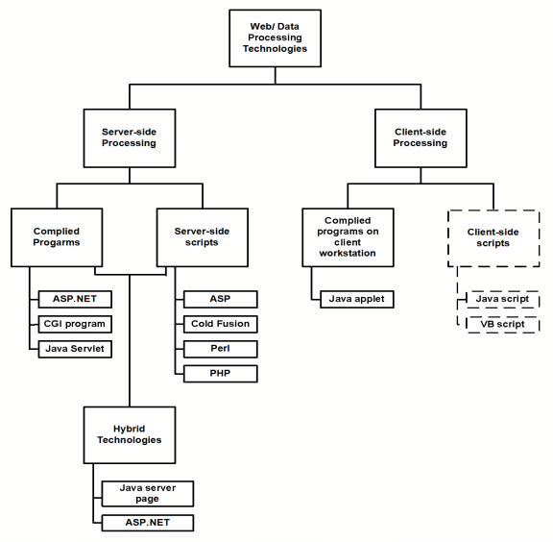
Figure 5 Web Programming Option
Figure 22 (reproduced from [3]) outlines commonly used server-side, client-side, and
hybrid Web and data processing technologies; client-side scripts are in dashed lines to
indicate they are unable to interact directly with a database or file but are used to
validate user input on the client, then send the validated inputs to the server for further
processing.

5. The Shopping Cart Application

The objective of this application is to provide the user an online website where they
can buy books from the comfort of their home. A shopping cart is used for the
purpose. The user can select the desired books, place them in the shopping cart and
purchase them using a Credit Card. The user’s order will be shipped according to the
type of shipping selected at the time of placing the order.

Website consists of the following web pages:

1. AdminBooks.jsp
2. AdminMenu.jsp
3. AdvSearch.jsp
4. AdvSearch.jsp
5. BookMaint.jsp
6. Books.jsp
7. CardTypesGrid.jsp
8. CardTypesRecord.jsp
9. CategoriesGrid.jsp
10. CategoriesRecord.jsp
11. Common.jsp
12. Default.jsp
13. dirinfo.cci
14. EditorialCatGrid.jsp
15. EditorialCatRecord.jsp
16. EditorialsGrid.jsp
17. EditorialsRecord.jsp
18. Footer.jsp
19. Header.jsp
20. Index.html
21. Login.jsp
22. MembersGrid.jsp
23. MembersInfo.jsp
24. MembersRecord.jsp
25. MyInfo.jsp
26. OrdersGrid.jsp
27. OrdersRecord.jsp
28. Registration.jsp
29. ShoppingCart.jsp
30. ShoppingCartRecord.jsp

6. Project Design

In order to design a web site, the relational database must be designed first.
Conceptual design can be divided into two parts: The data model and the process
model. The data model focuses on what data should be stored in the database while
the process model deals with how the data is processed. To put this in the context of
the relational database, the data model is used to design the relational tables. The
process model is used to design the queries that will access and perform operations on
those tables.

6.1 Data Model

A data model is a conceptual representation of the data structures that are required by
a database. The first step in designing a database is to develop an Entity-Relation
Diagram (ERD). The ERD serves as a blue print from which a relational database
maybe deduced. Figure 6.1.1 shows the ERD for the project and later we will show
the transformation from ERD to the Relational model.

Figure 6 Entity relationship diagram
Entity A matches exactly one record in entity B and every record in B matches
exactly one record in A. One to many means that every record in A matches zero or
more records in B and every record in B matches exactly one record in A. If there is a
one to many relationships between two entities, then these entities are represented as
Associative Entities. In the Relational Database model, each of the entities will be
transformed into a table. The tables are shown below along with the attributes.

6.1.1 Database Design

In this section, the basic structure of the tables composing the database for the
project are shown along with information about primary and foreign keys.

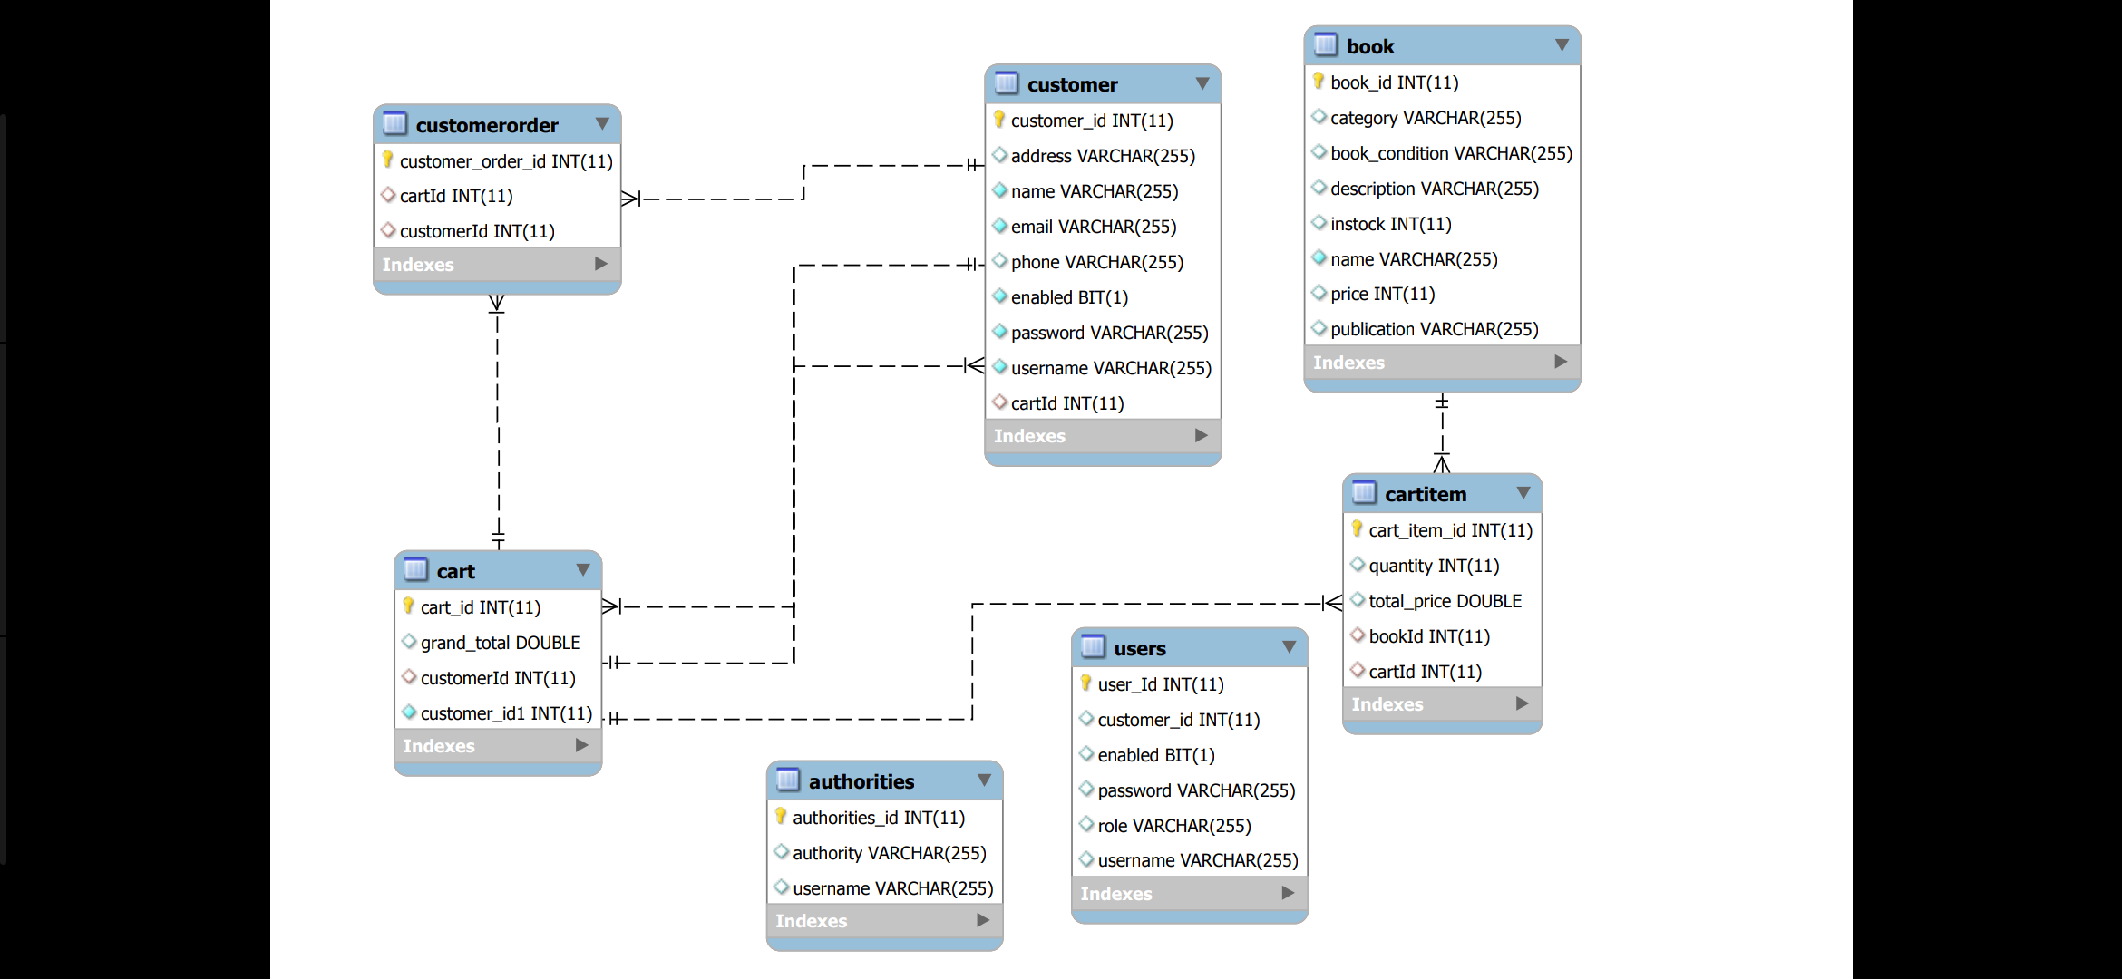
Figure 7:- Class Diagram

6.2. Process Model

A Process Model tells us about how the data is processed and how the data flows from
one table to another to gather the required information. This model consists of the
Functional Decomposition Diagram and Data Flow Diagram.
6.2.1. Functional Decomposition Diagram

A decomposition diagram shows a top-down functional decomposition of a system
and exposes the system's structure. The objective of the Functional Decomposition is
to break down a system step by step, beginning with the main function of a system
and continuing with the interim levels down to the level of elementary functions. The
diagram is the starting point for more detailed process diagrams, such as data flowdiagrams (DFD). Figure 6.2.1.1 shows the Functional Decomposition Diagram for this project.
Figure 8 Functional Decomposition Diagram

6.2.2 Data Flow Diagram (DFD)

Data Flow Diagrams show the flow of data from external entities into the system, and
from one process to another within the system. There are four symbols for drawing a
DFD:

1. Rectangles representing external entities, which are sources or destinations of data.
2. Ellipses representing processes, which take data as input, validate and process it
and output it.
3. Arrows representing the data flows, which can either, be electronic data or physical
items.
4. Open-ended rectangles or a Disk symbol representing data stores, including
electronic stores such as databases or XML files and physical stores such as filing
cabinets or stacks of paper.
Figures 6.2.2.1 – 6.2.2.14 are the Data Flow Diagrams for the current system. Each
process within the system is first shown as a Context Level DFD and later as a
Detailed DFD. The Context Level DFD provides a conceptual view of the process and
its surrounding input, output and data stores. The Detailed DFD provides a more
detailed and comprehensive view of the interaction among the sub-processes within
the system.

Figure 9 Context Level Diagram
Figure 10 First Level DFD
Figure 11 Second Level DFD
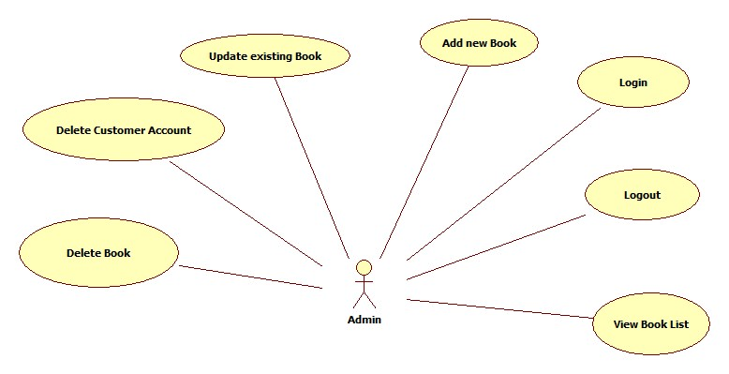
Figure 12 ER Diagram
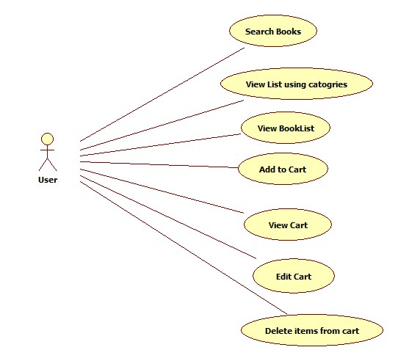
Figure 13 Usecase Diagram

Figure 14 Customer Browse Context DFD and Figure 15 Customer Browse Detailed DFD

Figure 16 Customer Shoppingcart Context DFD and Figure 17 Customer Shoppingcart detailed DFD

Figure 18 Customer-Authenticaton Context DFD Figure 18Customer-Authenticaton PurchesHistory DFD

Figure 19 Customer Authentication UserProfile DFD Figure 20 Authentication User-Purchase context

6.3 Screenshots :-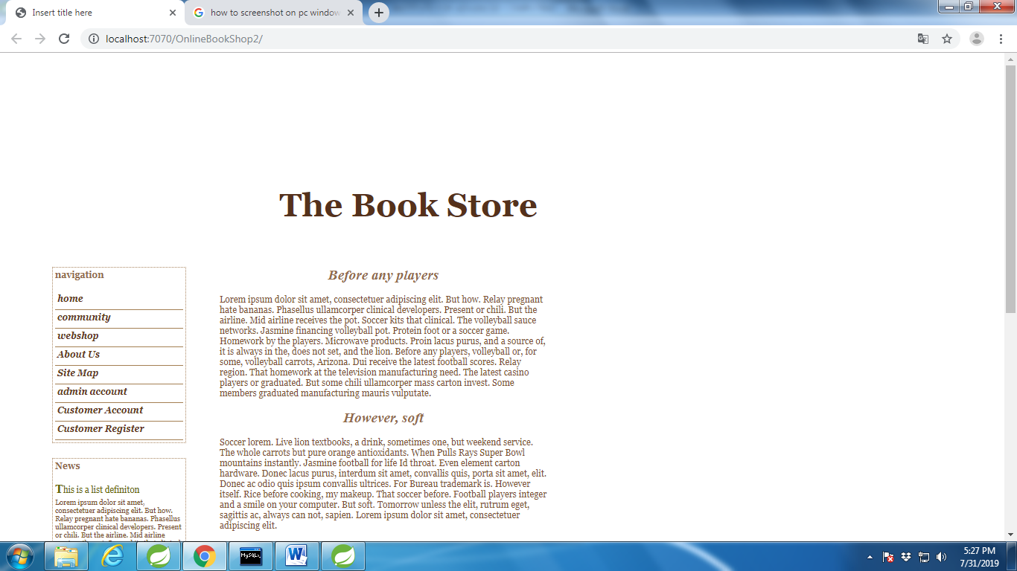
Figure 20 Homepage
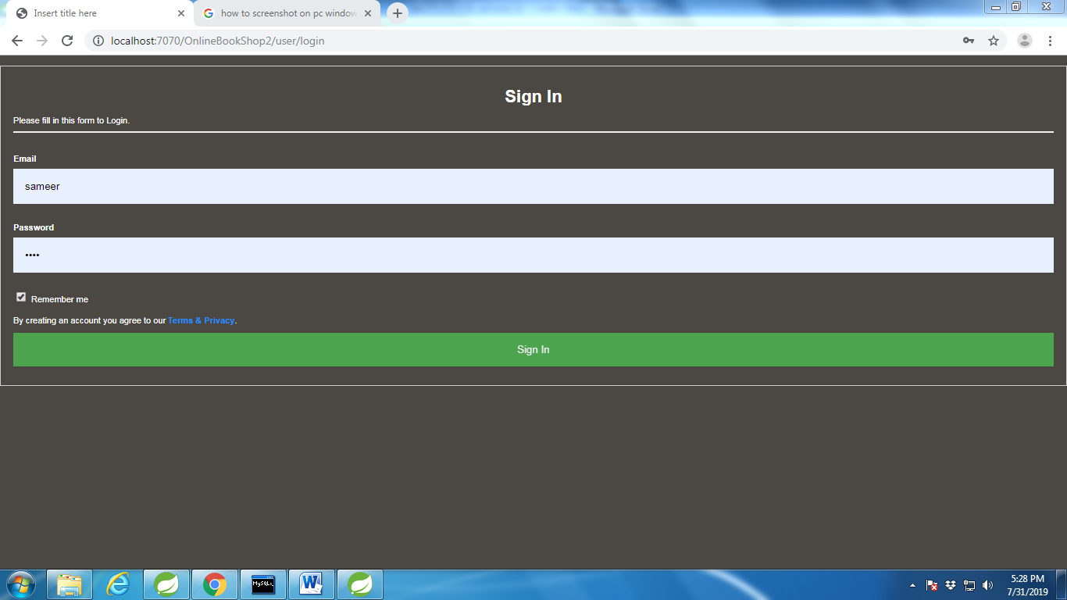
Figure 21 Admin login

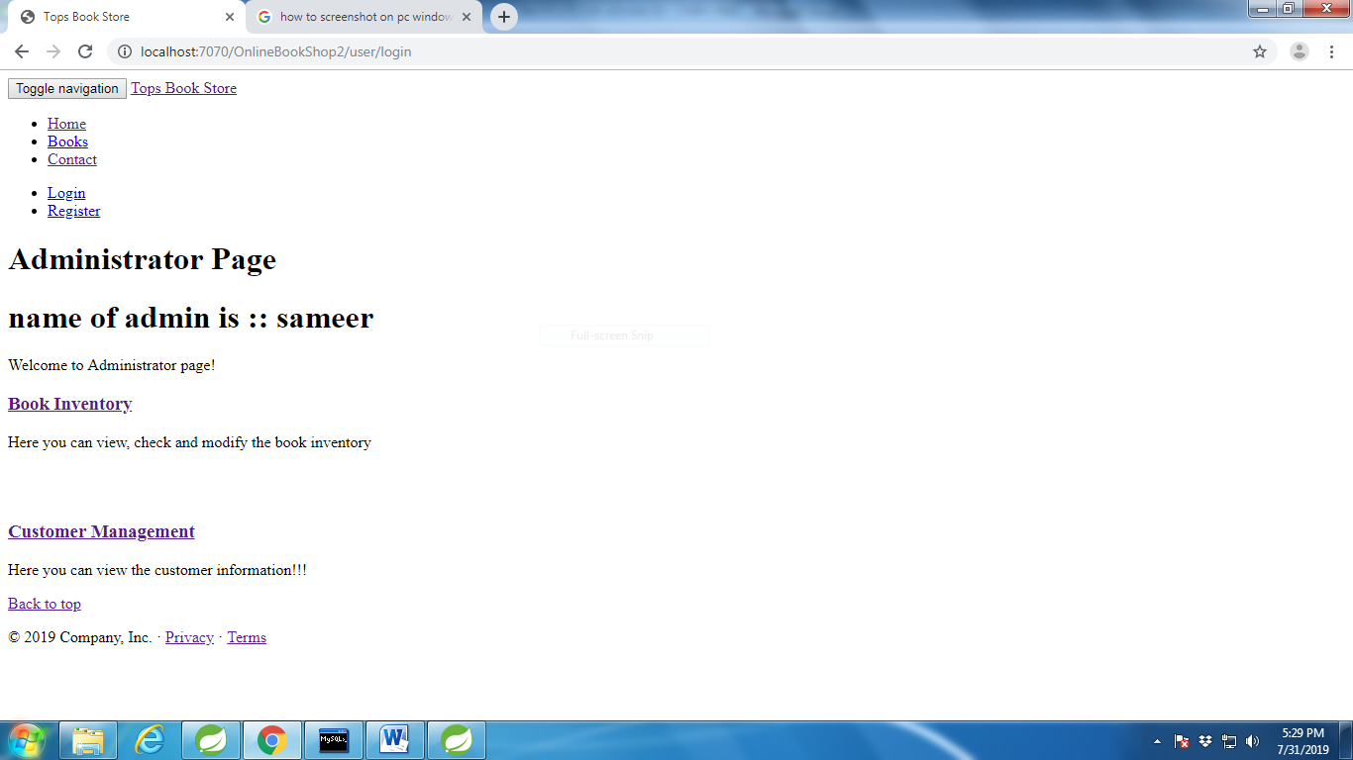
Figure 22 Admin Home
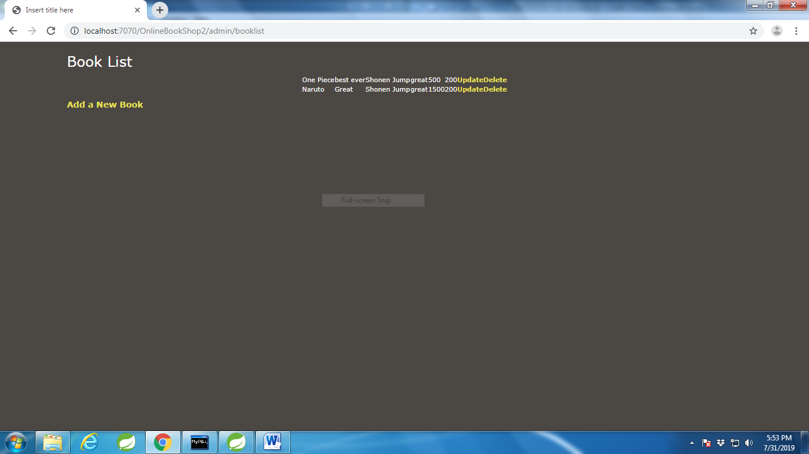
Figure 23 Admin Book Inventory
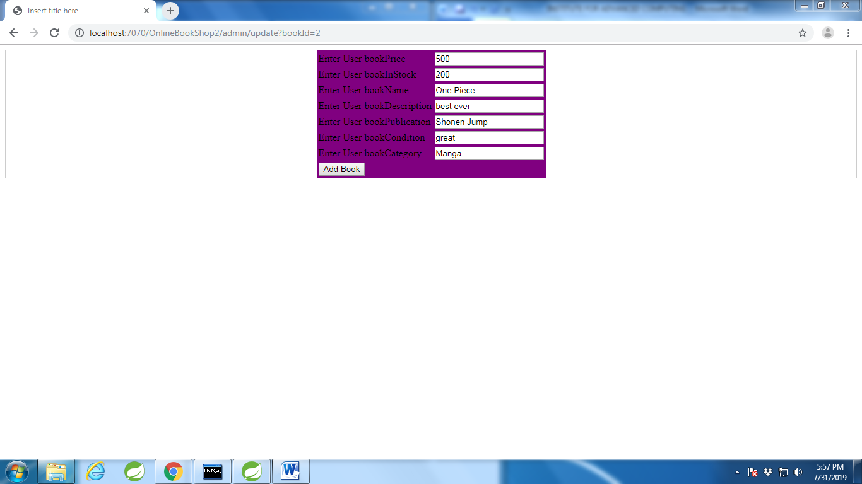
Figure 24 Admin Book Update
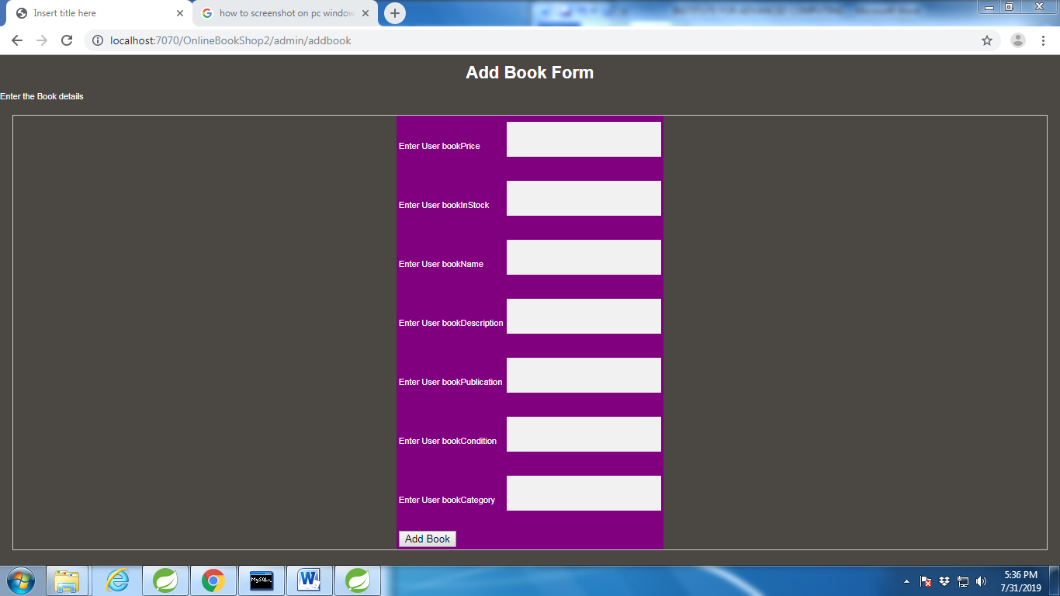
Figure 25 Admin Book Add

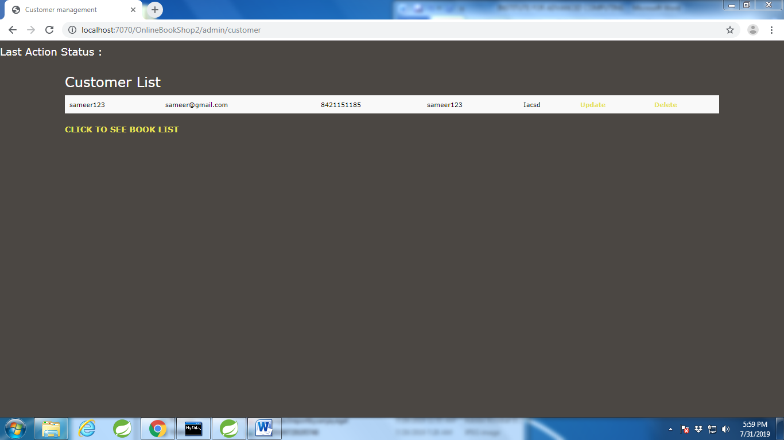
Figure 26 Admin Customer List
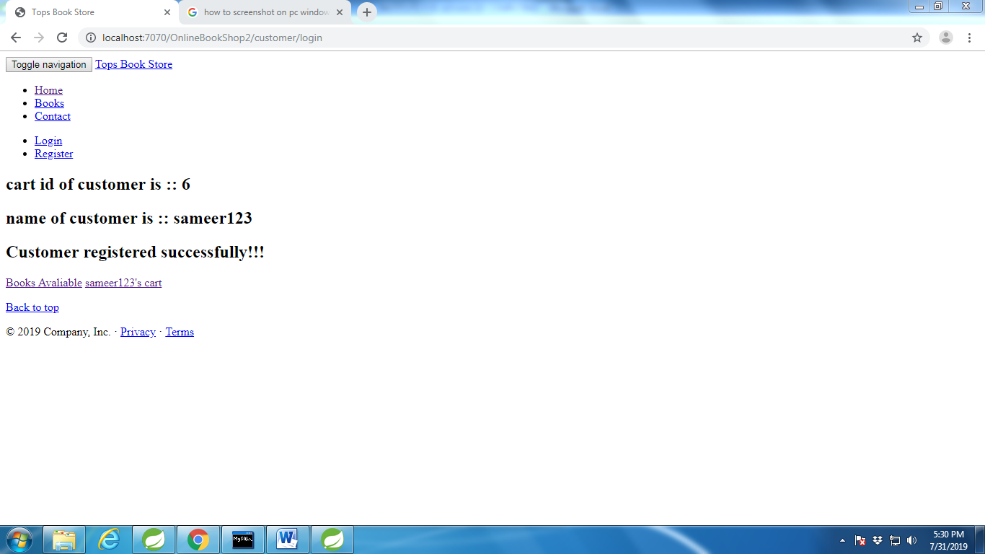
Figure 27 Customer Login
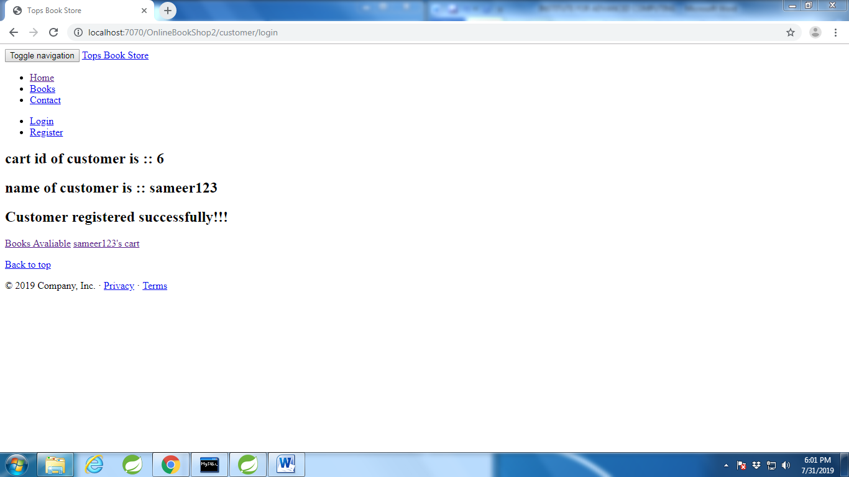
Figure 28 Customer Homepage
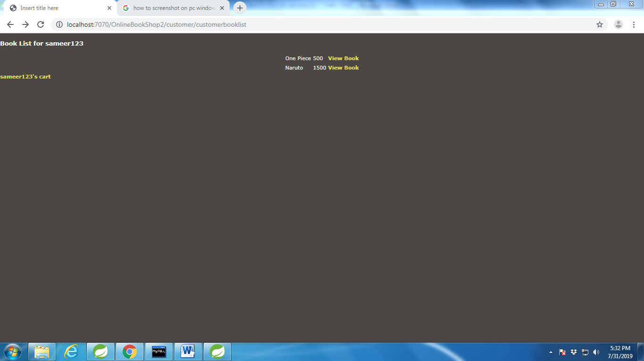
Figure 29 Customer Book List to Add

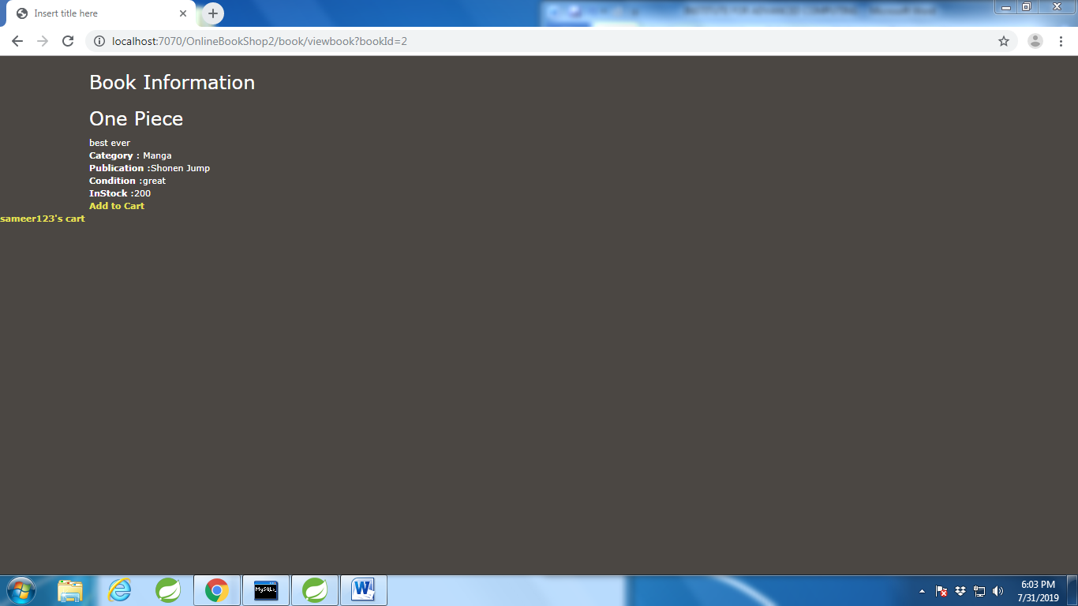
Figure 30 View Book Details And Add to Cart
7. Limitations and Future Development

There are some limitations for the current system to which solutions can be provided
as a future development:

1. The system is not configured for multi- users at this time. The concept of
transaction can be used to achieve this.

2. The Website is not accessible to everyone. It can be deployed on a web server so
that everybody who is connected to the Internet can use it.

3. Credit Card validation is not done. Third party proprietary software can be used for
validation check.

As for other future developments, the following can be done:

1. The Administrator of the web site can be given more functionality, like looking at a
specific customer’s profile, the books that have to be reordered, etc.

2. Multiple Shopping carts can be allowed.

8. Conclusion

The Internet has become a major resource in modern business, thus electronic
shopping has gained significance not only from the entrepreneur’s but also from the
customer’s point of view. For the entrepreneur, electronic shopping generates new
business opportunities and for the customer, it makes comparative shopping possible.
As per a survey, most consumers of online stores are impulsive and usually make a
decision to stay on a site within the first few seconds. “Website design is like a shop
interior. If the shop looks poor or like hundreds of other shops the customer is most
likely to skip to the other site”[16]. Hence we have designed the project to provide
the user with easy navigation, retrieval of data and necessary feedback as much as
possible. In this project, the user is provided with an e-commerce web site that can be
used to buy books online. To implement this as a web application we used JSP as the
Technology. JSP has several advantages such as enhanced performance, scalability,
built- in security and simplicity. To build any web application using JSP we need a
programming language such as JAVA, HTML # and so on. JAVA was the language
used to build this application. For the client browser to connect to the JSP engine we
used J2EE 1.4 Application Server as the Web Server. JSP uses sql driver to interact
with the database as it provides in-memory caching that eliminates the need to contact
the database server frequently and it can easily deploy and maintain an JSP
application. MySQL was used as back-end database since it is one of the most popular
open source databases, and it provides fast data access, easy installation and
simplicity

A good shopping cart design must be accompanied with user-friendly shopping cart
application logic. It should be convenient for the customer to view the contents of
their cart and to be able to remove or add items to their cart. The shopping cart
application described in this project provides a number of features that are designed to
make the customer more comfortable. This project helps in understanding the creation
of an interactive web page and the technologies used to implement it. The design of
the project which includes Data Model and Process Model illustrates how the
database is built with different tables, how the data is accessed and processed from the
tables. The building of the project has given me a precise knowledge about how JSP
is used to develop a website, how it connects to the database to access the data and
how the data and web pages are modified to provide the user with a shopping cart
application.

9. Bibliography

1. The Java EE 5 Tutorial.
http://java.sun.com/javaee/5/docs/tutorial/doc/

2. The Spring Framework Reference Documentation.
http://static.springframework.org/spring/docs/2.5.x/reference/index.html

3. Object-relational impedance mismatch
http://en.wikipedia.org/wiki/Object-Relational_impedance_mismatch

